
Chapter X: The Orchestrated Objective Reduction Theory of Consciousness: Quantum Processes in Brain Microtubules
Introduction
The Orchestrated Objective Reduction (Orch OR) theory, developed by Sir Roger Penrose and Stuart Hameroff, represents one of the most ambitious attempts to explain consciousness through fundamental physics. This theory proposes that consciousness arises from quantum computations occurring within microtubules—cylindrical protein structures found in the cytoskeleton of neurons. Unlike conventional neuroscientific approaches that view consciousness as emerging from classical neural network activity, Orch OR posits that consciousness is fundamentally a quantum phenomenon, arising from orchestrated quantum state reductions linked to the structure of spacetime itself^{[1][2]}.
The theory emerged from the convergence of two distinct intellectual trajectories. Penrose, approaching from theoretical physics and mathematics, argued that human consciousness exhibits non-algorithmic properties that cannot be captured by classical computation, as demonstrated through Gödel's incompleteness theorems. Hameroff, working as an anesthesiologist, observed that anesthetic gases selectively eliminate consciousness while preserving many other brain functions, suggesting that consciousness might depend on specific molecular processes that anesthetics disrupt^{[3][4]}.
The Architecture of Microtubules
Molecular Structure and Assembly
Microtubules are hollow cylindrical polymers approximately 25 nanometers in external diameter with a 15-nanometer internal lumen. They are constructed from heterodimers of α- and β-tubulin proteins, each with a molecular weight of approximately 55 kilodaltons. These dimers polymerize in a head-to-tail fashion to form protofilaments, which then associate laterally to create the microtubule wall^{[5][6]}.
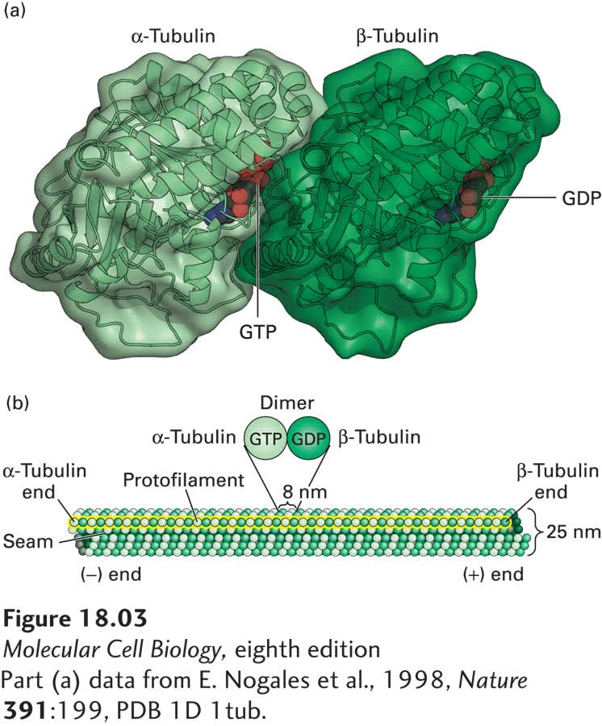
Structural and molecular details of tubulin dimers and microtubule protofilaments showing GTP and GDP binding sites and microtubule dimensions.
The tubulin dimer measures approximately 8 nanometers in length and contains two distinct nucleotide binding sites. The α-tubulin subunit binds GTP in a non-exchangeable manner at the N-site, while the β-tubulin subunit contains an exchangeable nucleotide binding site (E-site) that can hydrolyze GTP to GDP. This GTP hydrolysis is crucial for microtubule dynamics and may play a role in quantum state transitions within the Orch OR framework^{[5]}.
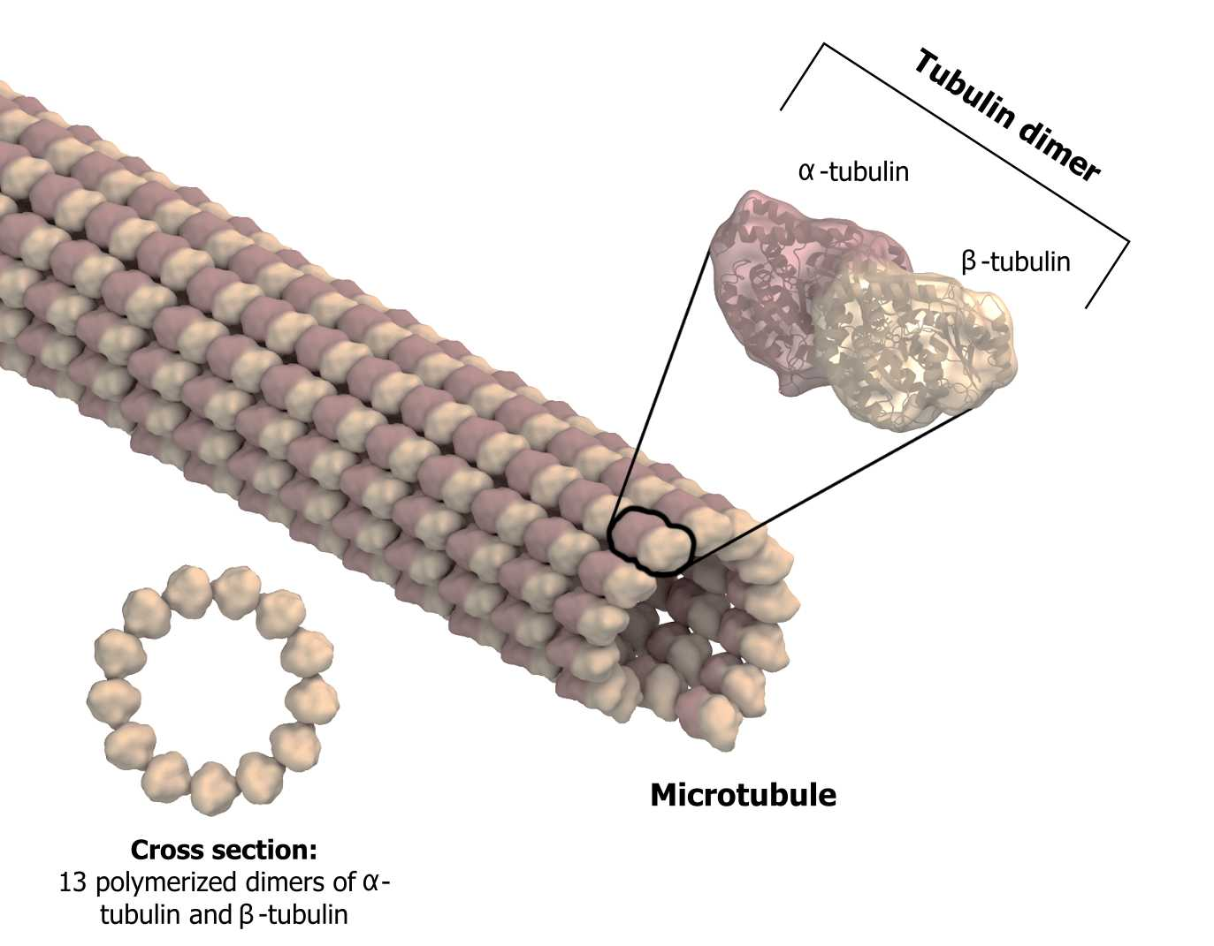
3D molecular structure of a microtubule showing alpha and beta tubulin dimers and a cross-sectional view of its 13 protofilaments.
Lattice Configurations and the Seam
Microtubules can adopt different lattice configurations, with the B-lattice being predominant in biological systems. In the B-lattice, lateral contacts between protofilaments occur between like subunits (α-α and β-β), except at a discontinuity called the seam where A-lattice contacts (α-β) occur. Most microtubules contain 13 protofilaments, though variations with 11-16 protofilaments exist^{[7][8]}.
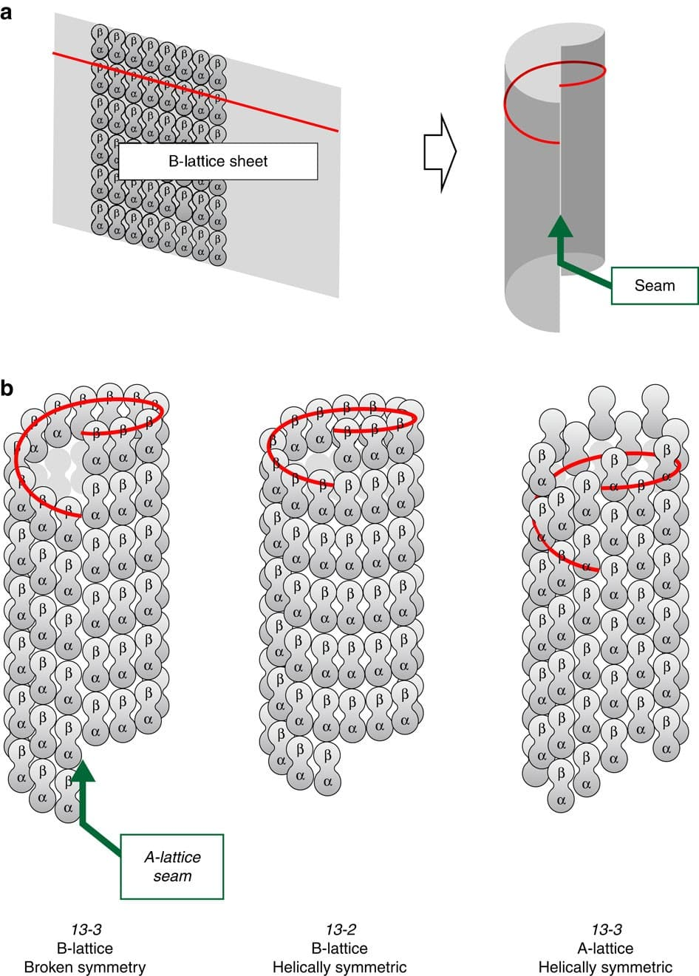
Microtubule lattice configurations showing A-lattice and B-lattice arrangements with seams and helical symmetry relevant to quantum processes in microtubules.
The seam represents a structural discontinuity that may have functional significance for quantum processes. Some researchers propose that the seam could serve as a site for quantum error correction or as a boundary condition affecting quantum state propagation along the microtubule^{[9][10]}.
Quantum Properties of Tubulin and Microtubules
Tryptophan Networks and Quantum Coherence
A key feature enabling quantum processes in microtubules is the presence of tryptophan amino acids within tubulin. Each tubulin monomer contains approximately four tryptophan residues, positioned at strategic locations within the protein structure. These aromatic amino acids possess large dipole moments and can support quantum coherent energy transfer through their π-electron systems^{[11][12][13]}.
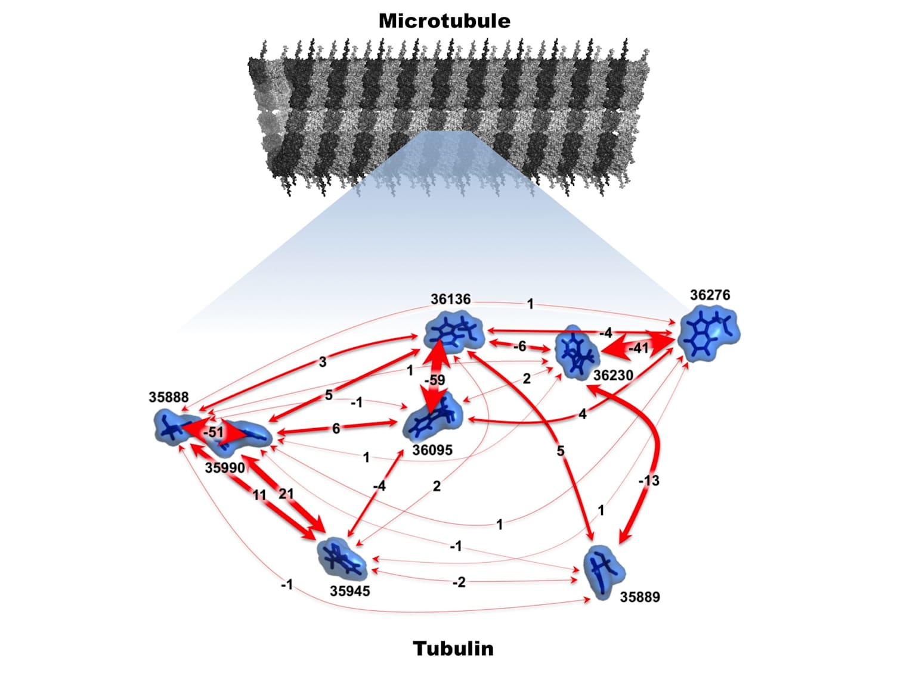
Molecular interactions within tubulin proteins composing microtubules, illustrating potential quantum processes relevant to the Orch-OR theory of consciousness.
The spacing between tryptophan residues ranges from 11.4 to 41.6 Angstroms, comparable to chromophore spacing in photosynthetic complexes known to exhibit quantum coherence. Computational studies have demonstrated that these tryptophan networks can support coherent energy transfer at physiological temperatures, with quantum beating effects lasting approximately 600 femtoseconds^{[11][12]}.
Quantum Channels and Anesthetic Binding
Within the tubulin structure, hydrophobic pockets containing aromatic amino acids form what Hameroff terms "quantum channels." These channels, characterized by their non-polar, "oil-like" environment, can support quantum dipole oscillations at specific frequencies. Anesthetic molecules, which are known to eliminate consciousness, bind preferentially within these quantum channels^{[14][15]}.
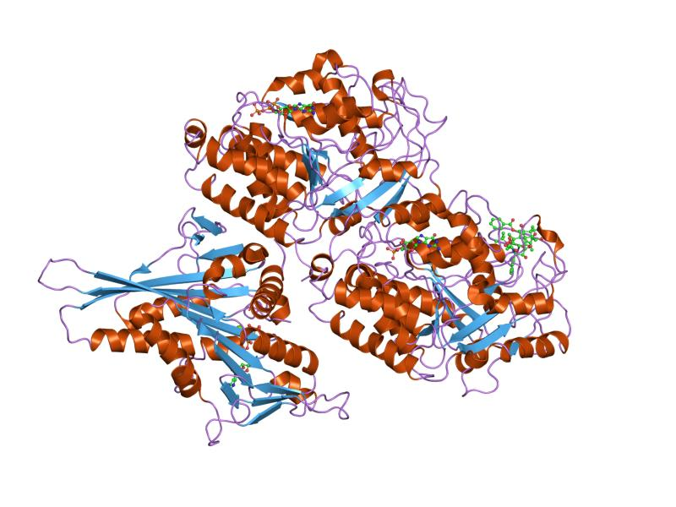
3D molecular structure of tubulin protein showing alpha helices, beta sheets, and bound ligands relevant to microtubule function.
Recent quantum chemistry calculations by Craddock and colleagues revealed that tubulin exhibits a prominent collective vibrational mode at 613 terahertz. Significantly, all tested anesthetic gases abolish this specific frequency mode in proportion to their anesthetic potency, while non-anesthetic molecules have no effect. This finding provides a direct link between quantum vibrations in microtubules and consciousness^{[16][17]}.
The Orchestrated Objective Reduction Mechanism
Quantum Superposition in Microtubules
According to Orch OR, tubulin proteins within microtubules can exist in quantum superposition states. Each tubulin dimer is proposed to act as a quantum bit (qubit), with different conformational states representing the basis states |0⟩ and |1⟩. Through dipole-dipole interactions and quantum tunneling, these qubits become entangled, creating a macroscopic quantum state extending across significant portions of the microtubule network^{[1][2]}.
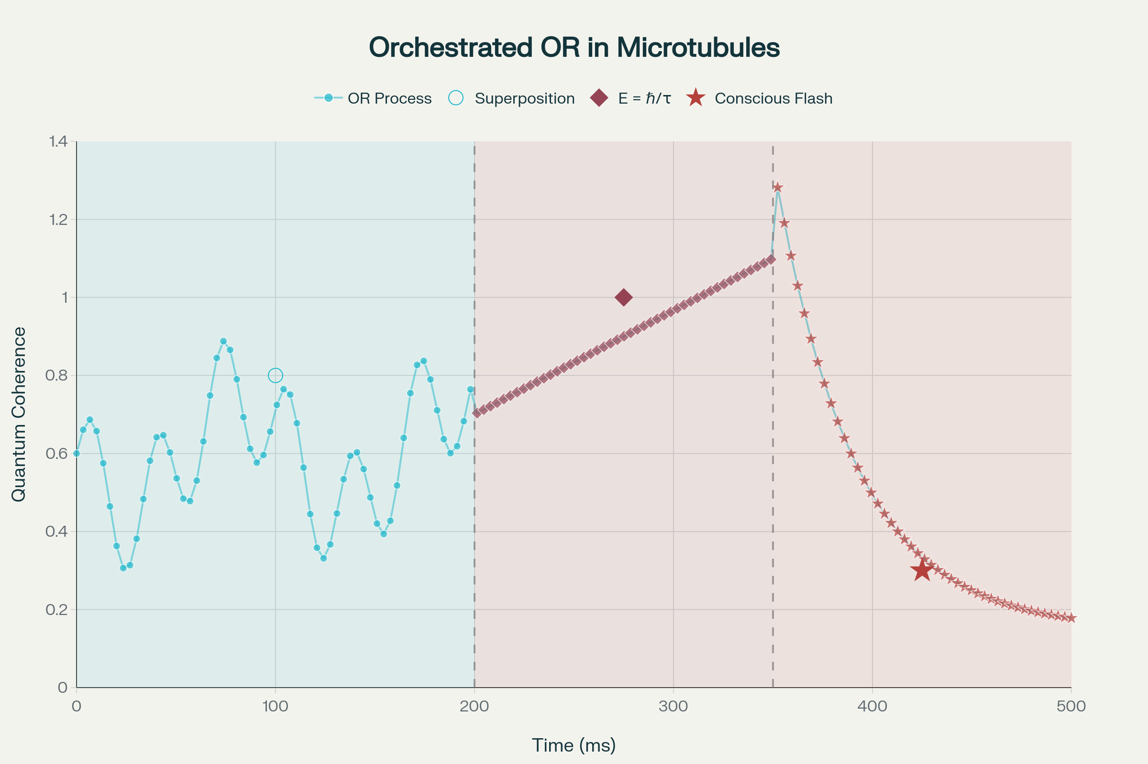
The Orchestrated Objective Reduction process: from quantum superposition to conscious experience
The quantum coherent state evolves according to the Schrödinger equation until it reaches a critical threshold. During this pre-conscious phase, quantum computation occurs through the interference and entanglement of tubulin states, processing information in a fundamentally non-algorithmic manner^{[3][4]}.
Objective Reduction and Spacetime Geometry
Penrose's contribution to Orch OR involves the mechanism by which quantum superpositions collapse—the objective reduction (OR) process. Unlike the Copenhagen interpretation, which requires an external observer, OR proposes that superpositions self-collapse when they reach a gravitational threshold^{[18][19]}.
The key equation governing OR is:
E = ℏ/τ
Where:
- E is the gravitational self-energy of the mass distribution in superposition
- ℏ is the reduced Planck constant
- τ is the coherence time until OR occurs
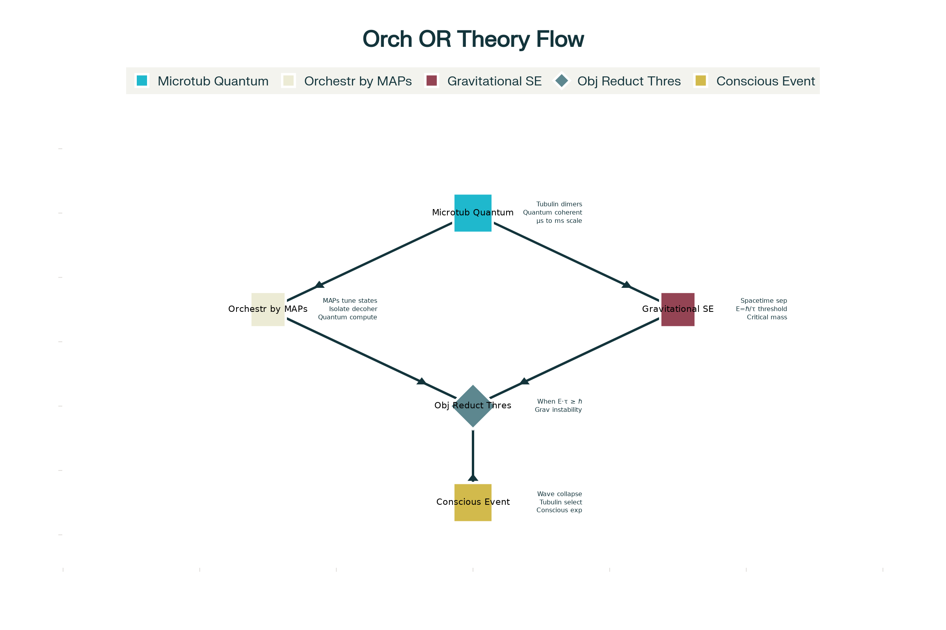
Complete flowchart of the Orchestrated Objective Reduction (Orch OR) theory
For conscious events, Penrose and Hameroff calculate that OR must occur with τ ranging from 25 to 500 milliseconds, corresponding to 40 Hz and 2 Hz brain rhythms respectively. This requires approximately 10^9 to 10^10 tubulins in coherent superposition^{[4][20]}.
The Role of Quantum Gravity
The OR process is fundamentally linked to quantum gravity. When a quantum system exists in superposition, each component state corresponds to a slightly different spacetime geometry. According to general relativity, these different geometries cannot coexist indefinitely. When the difference reaches one graviton level (the Planck scale), the superposition becomes unstable and must reduce to a single state^{[21][22][23]}.
This reduction is:
- Objective: It occurs due to an intrinsic threshold, not measurement
- Non-computable: The specific outcome cannot be algorithmically predicted
- Conscious: Each OR event corresponds to a moment of conscious experience
Orchestration Mechanisms
Microtubule-Associated Proteins (MAPs)
The "orchestration" in Orch OR refers to the biological mechanisms that organize and sustain quantum coherence until the OR threshold is reached. Microtubule-associated proteins (MAPs) play crucial roles in this process^{[24][25][26]}.
MAPs serve multiple functions in the Orch OR model:
- Structural stabilization: MAPs like tau and MAP2 bind to microtubules, potentially protecting quantum states from environmental decoherence
- Quantum isolation: During specific phases, MAPs may help isolate microtubule segments from thermal noise
- State preparation: MAPs could "tune" the quantum oscillations by modifying the local environment
- Inter-microtubule coupling: MAPs connecting adjacent microtubules may enable quantum entanglement across larger neural regions
Actin Gelation and Quantum Isolation
Hameroff proposes that cycles of actin gelation around microtubules provide temporal windows for quantum coherence. During the gel state, microtubules are isolated from environmental decoherence, allowing quantum superposition to build. During the liquid state, classical signaling and state preparation occur^{[14][27]}.
Water and Quantum Coherence
Recent research has highlighted the role of ordered water within microtubules. The microtubule lumen contains structured water that may support additional quantum processes. Water nanoclusters can exhibit terahertz vibrations that couple with tubulin quantum states, potentially extending coherence times^{[28][29]}.
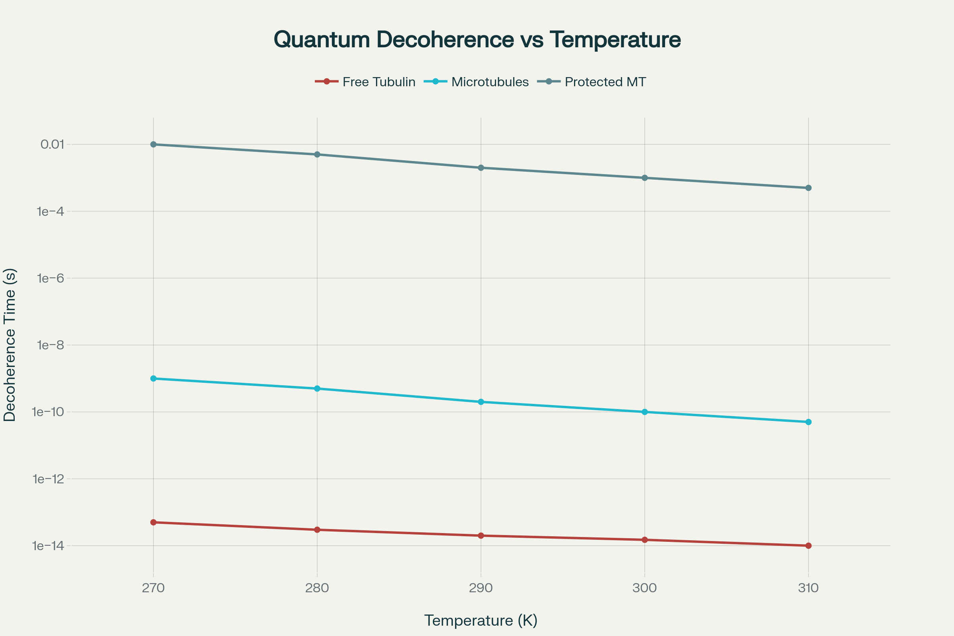
Quantum coherence mechanisms and decoherence times in microtubules
Experimental Evidence and Recent Validations
Anesthesia Studies
The most compelling experimental support for Orch OR comes from anesthesia research. In 2024, Wiest and colleagues at Wellesley College demonstrated that microtubule-stabilizing drugs significantly delay anesthetic-induced unconsciousness in rats. When rats received epothilone B (which binds to and stabilizes microtubules) before isoflurane anesthesia, they maintained consciousness significantly longer than controls^{[30][31][32]}.
This finding is crucial because it directly links microtubule function to consciousness. As Wiest notes: "Since we don't know of another (i.e., classical) way that anesthetic binding to microtubules would generally reduce brain activity and cause unconsciousness, this finding supports the quantum model of consciousness"^{[30]}.
Quantum Effects in Warm Brain Tissue
A major criticism of Orch OR has been the decoherence problem—the claim that quantum states cannot survive in the "warm, wet, noisy" environment of the brain. However, recent evidence challenges this assumption:
- Extended Coherence Times: Revised calculations accounting for topological protection, non-Markovian dynamics, and biological shielding show coherence times of 10^-4 to 10^-3 seconds at body temperature—sufficient for biological quantum computation^{[33][29]}.
- Quantum Entanglement Detection: In 2022, Kerskens and Pérez reported detecting quantum entanglement in brain tissue using MRI techniques, providing direct evidence for quantum effects in living neural tissue^{[34]}.
- Superradiance in Microtubules: Studies of tryptophan networks in microtubules have demonstrated superradiant states—collective quantum excitations that are more robust against decoherence than individual quantum states^{[35]}.
Vibrational Spectroscopy
Advanced spectroscopic studies have revealed specific quantum signatures in microtubules:
- 613 THz Peak: The discovery that anesthetics specifically target the 613 THz vibrational mode in tubulin provides a direct link between quantum dynamics and consciousness^{[16][17]}.
- Quantum Beats: Time-resolved spectroscopy has detected quantum beating patterns in microtubule preparations, consistent with coherent energy transfer^{[11][12]}.
Implications for Understanding Consciousness
Non-Computability and Free Will
The OR process introduces genuine non-computability into brain function. Unlike deterministic classical processes or random quantum measurements, OR represents a third option—a non-algorithmic selection influenced by fundamental spacetime geometry. This provides a potential basis for free will that avoids both determinism and mere randomness^{[4][36]}.
The Binding Problem
Orch OR offers a solution to the binding problem—how disparate neural processes combine into unified conscious experience. Quantum entanglement across microtubule networks could create a global quantum state that naturally binds information into coherent conscious moments^{[1][14]}.
Temporal Experience
The discrete nature of OR events, occurring every 25-500 milliseconds, may explain the "specious present"—our sense of experiencing extended moments rather than infinitesimal instants. Each OR event creates a conscious moment, with sequences forming the stream of consciousness^{[36][19]}.
Criticisms and Ongoing Debates
The Decoherence Challenge
Critics argue that biological systems are too noisy for quantum coherence. However, recent evidence of quantum effects in photosynthesis, avian navigation, and enzyme catalysis has weakened this objection. The revised decoherence calculations and experimental findings of quantum entanglement in brain tissue further support the feasibility of Orch OR^{[9][37][38]}.
The Gödelian Argument
Some philosophers challenge Penrose's use of Gödel's theorems, arguing that humans might be inconsistent reasoners or unable to recognize their own Gödel sentences. Penrose responds that mathematical understanding provides "self-evident" consistency recognition that transcends formal proof^{[39]}.
Alternative Explanations
Researchers have proposed alternative explanations for the experimental findings:
- Classical resonance effects might explain some observations
- Anesthetic effects on microtubules might be secondary to membrane effects
- Quantum-like phenomena might emerge from classical complexity
However, the growing body of evidence specifically linking quantum processes in microtubules to consciousness makes these alternatives increasingly difficult to maintain.
Future Directions
Experimental Tests
Several experiments could definitively test Orch OR:
- Direct Quantum State Detection: Development of techniques to detect quantum superposition in living neurons
- Temporal Correlation Studies: Measuring the relationship between OR events and conscious perception timing
- Quantum Information Processing: Demonstrating non-classical information processing in microtubule networks
Technological Applications
Understanding quantum processes in microtubules could lead to:
- Novel anesthetic agents with fewer side effects
- Quantum-inspired treatments for disorders of consciousness
- Bio-inspired quantum computing architectures
- Brain-computer interfaces utilizing quantum channels
Theoretical Developments
Future theoretical work should address:
- Detailed mechanisms of biological quantum error correction
- The role of topological quantum effects in microtubules
- Integration with broader theories of quantum gravity
- Mathematical formalization of the consciousness-spacetime connection
Conclusion
The Orchestrated Objective Reduction theory represents a profound synthesis of neuroscience, quantum mechanics, and fundamental physics. By proposing that consciousness arises from orchestrated quantum processes in microtubules that undergo gravitationally-induced objective reduction, Penrose and Hameroff have created a framework that addresses many puzzles about consciousness while making specific, testable predictions.
Recent experimental evidence, particularly from anesthesia studies and quantum coherence observations, has moved Orch OR from the realm of speculation toward empirical validation. While challenges remain, the theory's ability to explain the non-algorithmic nature of consciousness, the mechanism of anesthesia, and the binding of conscious experience makes it increasingly compelling.
As we stand at the intersection of neuroscience and quantum physics, Orch OR suggests that understanding consciousness requires not just studying neural networks but delving into the quantum foundations of reality itself. The implications extend beyond neuroscience to fundamental questions about the nature of time, causation, and our place in the universe. Whether ultimately proven correct or not, Orch OR has already transformed our conception of what consciousness might be and where in the brain we should look for its physical basis.
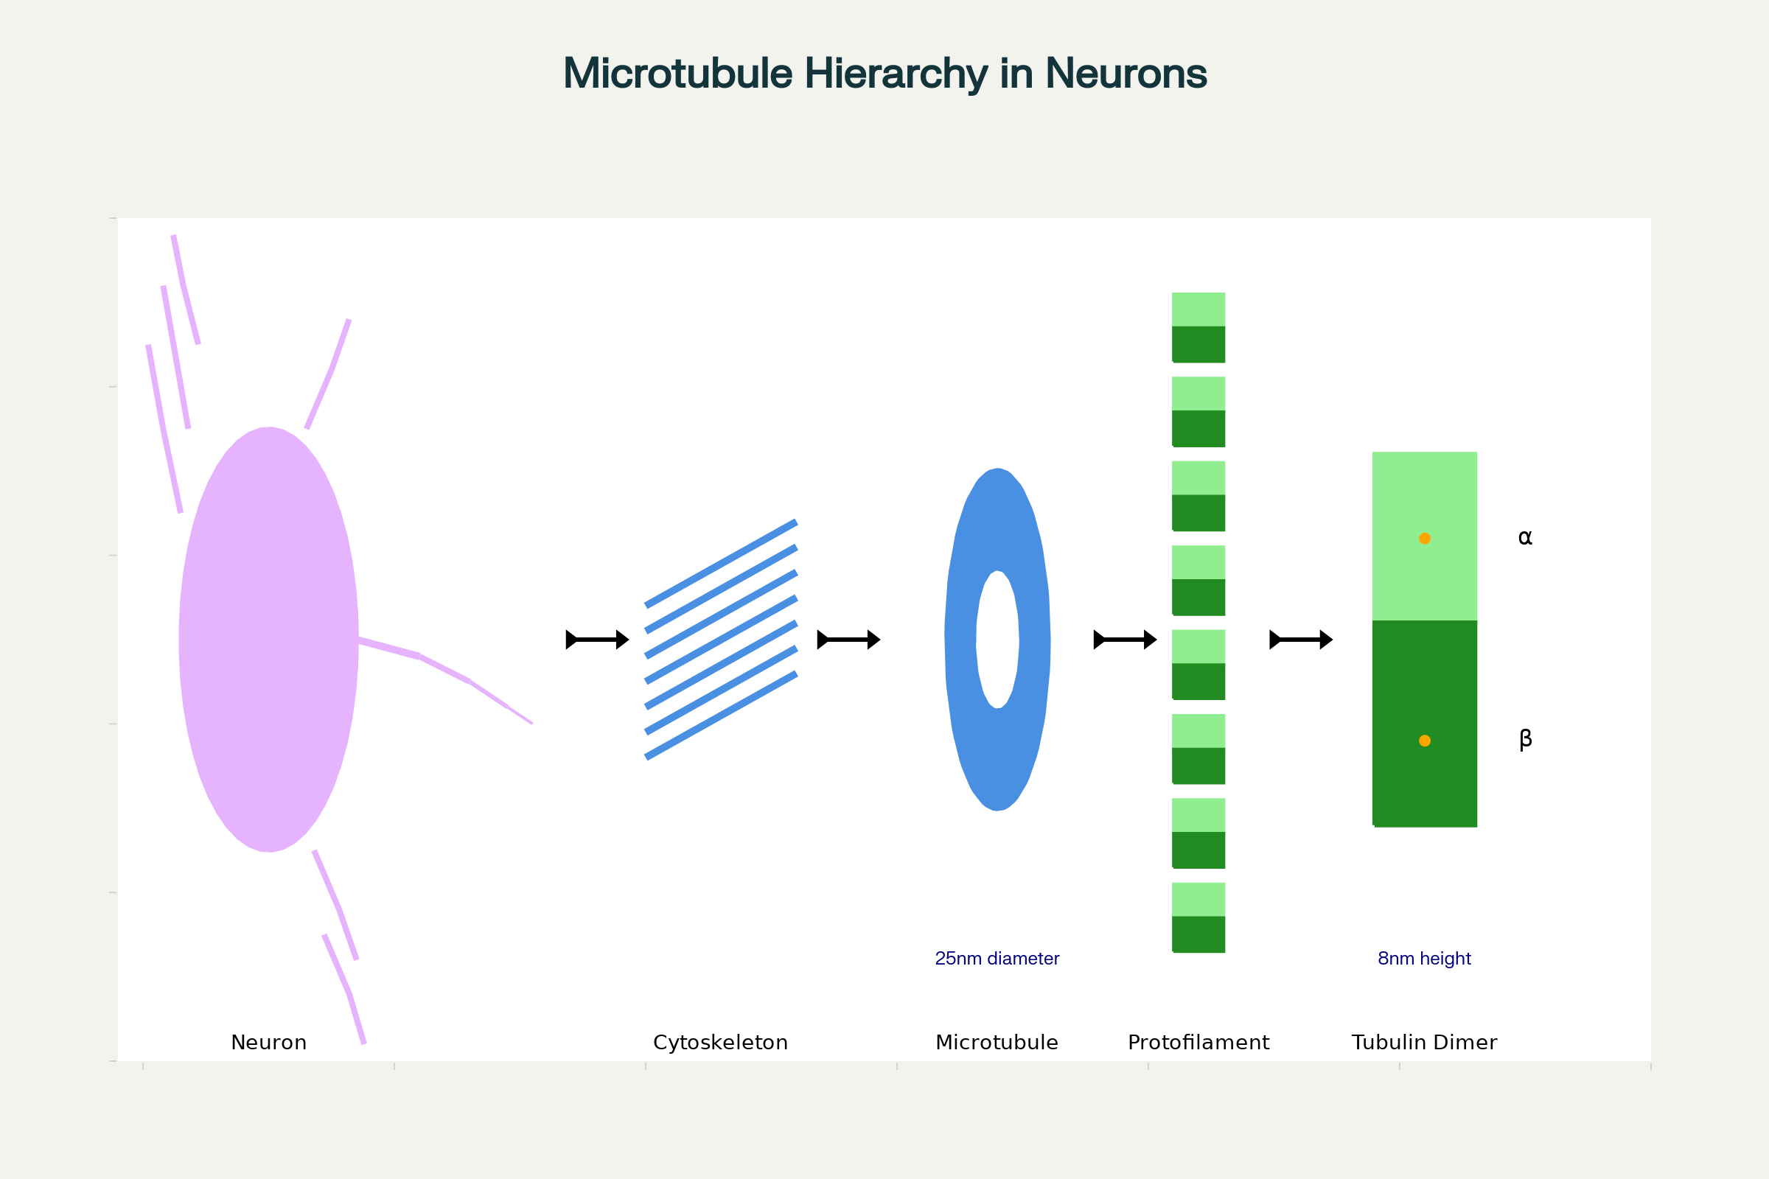
Hierarchical organization of microtubules in neurons, from the cellular to molecular level
⁂

- https://en.wikipedia.org/wiki/Orchestrated_objective_reduction
- https://papers.ssrn.com/sol3/papers.cfm?abstract_id=5013981
- https://pmc.ncbi.nlm.nih.gov/articles/PMC4191094/
- https://experts.arizona.edu/en/publications/consciousness-the-brain-and-spacetime-geometry
- https://www.youtube.com/watch?v=vQKeTruajIg
- https://www.youtube.com/watch?v=kE9jp4fEOzk
- https://arxiv.org/html/2505.20364v1
- https://pubmed.ncbi.nlm.nih.gov/11349432/
- https://www.sciencedirect.com/science/article/pii/S1571064513001188
- https://pmc.ncbi.nlm.nih.gov/articles/PMC8393322/
- https://www.scirp.org/pdf/jmp_2022122616010934.pdf
- https://brill.com/view/journals/time/12/2/article-p158_010.xml?language=en
- https://hameroff.arizona.edu/research-overview/orch-or
- https://www.sciencedaily.com/releases/2014/01/140116085105.htm
- https://royalsocietypublishing.org/doi/10.1098/rsif.2014.0677
- https://www.youtube.com/watch?v=Bc44YTFTMxA
- http://www.esalq.usp.br/lepse/imgs/conteudo_thumb/Orchestrated-Objective-Reduction-of-Quantum-Coherence-in-Brain-Microtubules.pdf
- https://www.reddit.com/r/consciousness/comments/1d0g5g0/brain_really_uses_quantum_effects_new_study_finds/
- https://citeseerx.ist.psu.edu/document?repid=rep1&type=pdf&doi=afa292a0602e947de8c8058dc812a68f1c186fbf
- https://www.newswise.com/articles/think-tank-smears-orch-or-quantum-theory-of-consciousness
- https://www.ias.ac.in/article/fulltext/pram/094/0163
- https://www.jove.com/science-education/v/11909/microtubule-associated-proteins-maps
- https://scitechdaily.com/groundbreaking-study-affirms-quantum-basis-for-consciousness-a-paradigm-shift-in-understanding-human-nature/
- https://www.youtube.com/watch?v=JelwUMQFc0I&vl=en
- https://digitalcommons.lmu.edu/cgi/viewcontent.cgi?article=1021&context=phys_fac
- https://journals.physiology.org/doi/abs/10.1152/physrev.1995.75.4.835
- https://neurosciencenews.com/quantum-process-consciousness-27624/
- https://pubmed.ncbi.nlm.nih.gov/33232193/
- https://www.myofascialrelease.com/downloads/articles/Quantum_Coherence_In_Microtubules_A_Neural_Basis_For_Emergent_Consciousness.pdf
- https://www.scribd.com/document/467656348/penrose1996-pdf
- https://app.jove.com/science-education/v/11909/microtubule-associated-proteins-maps?playlist=1671404&isFrc=true
- https://www.caltech.edu/campus-life-events/calendar/anesthetic-action-links-consciousness-to-quantum-vibrations-in-brain-microtubules
- https://www.medcraveonline.com/JNSK/JNSK-11-00471.pdf
- https://www.preprints.org/manuscript/202504.2176/v1
- https://quantumzeitgeist.com/quantum-gravity-model-links-matter-to-einsteins-general-relativity/
- https://pmc.ncbi.nlm.nih.gov/articles/PMC5739964/
- https://pmc.ncbi.nlm.nih.gov/articles/PMC12060853/
- https://www.youtube.com/watch?v=dDb4eOnTBi0
- https://pubmed.ncbi.nlm.nih.gov/9428769/

